**Assignment 2: Draughts App Report**

I feel I have been fairly successful with some parts of this assignment, however in others I have struggled to find a working solution. I believe I have met FR1 very successfully, as I can create a new game, with all the pieces in the correct positions and load the previous one if it exists without any difficulty. FR2 I found incredibly difficult as I couldn’t seem to devise an algorithm that would fit all of the rules of draughts. I can move pieces around perfectly, by simply clicking on the piece you would like to move, and then clicking on the square you wish to move it to. However, taking pieces is often temperamental, as it will sometimes not take the piece, or will deselect the piece you are controlling and change turns. I have also not implemented automatic mandatory capture, however I have successfully implemented mandatory capture as the system will not let the game change turns or move any other piece other than the one that has captures to make.

As in FR3, captured pieces are removed immediately from the board, and when a piece reaches the opposite end of the board, it becomes a king as in FR4. I struggled to devise a way of moving horizontally without having the king be able to “scroll” over the edge of the board to the opposite side. I have fully met FR5; when the game is one, a toast is displayed that shows the name of the winner, a point is added to their score in the database and the winner is highlighted in blue on the screen. I have also fully met FR6 – I use a content provider connected to a SQLite database with three tables: one for the game, one for users and one for settings. The game is resurrected by using the load game button rather than the new game button, and it loads the game state exactly as it was left after leaving the activity or the app. Players can register themselves as in FR7 by going to Leaderboard screen and pressing the new user button. They are then prompted to add a name and description before their details are added to the system. This list is used again when pressing the new game button – A fragment is displayed containing the list of users. After the user picks the two players they are sent to the game activity. The Leaderboard screen also holds the Leaderboard, which displays every user in descending order of their points. I have successfully implemented the display settings of the board, however I was unable to fully complete FR10 as I could not implement the Armenian rule set.

**Screenshots**

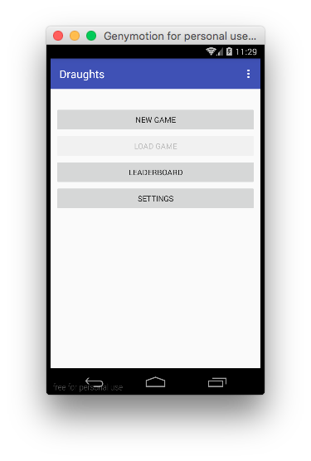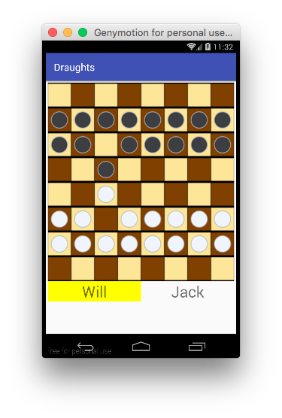

**Initial Screen Before taking a piece**

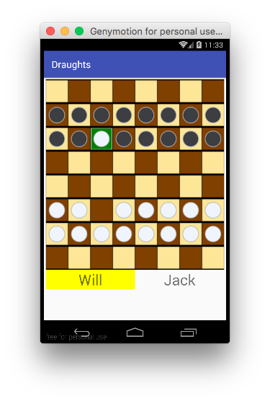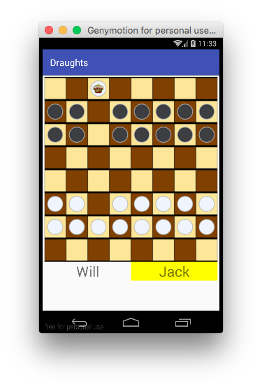

**After taking a piece Last piece taken and becoming a king**

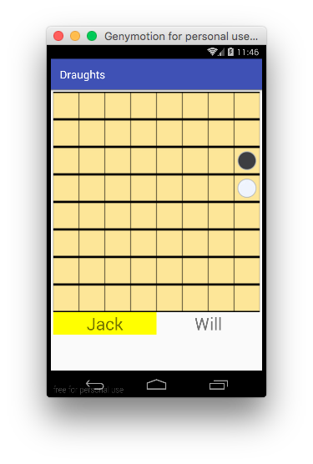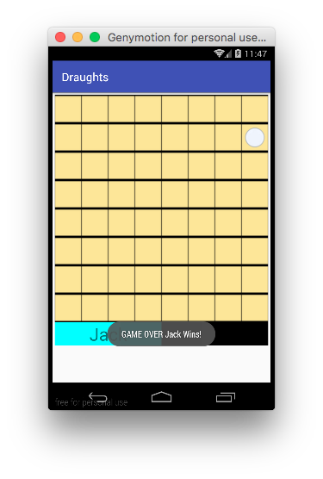

**Before winning the game After winning the game**

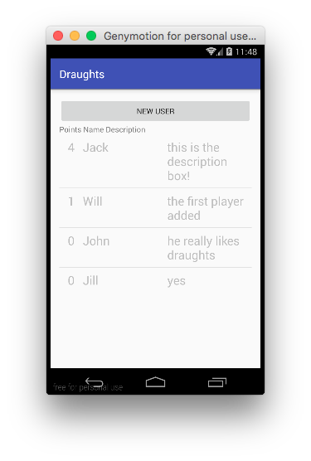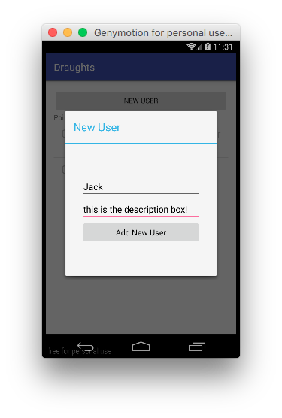

**Leaderboard sorted by score Adding a user**